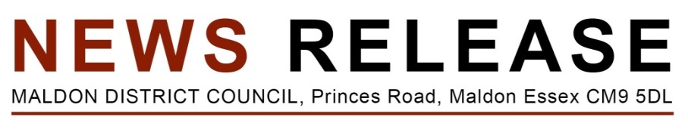
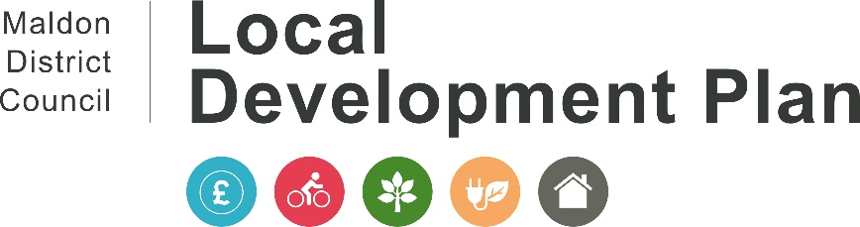
14 January 2022
Have Your Say on Planning for Future Development in the Maldon District

A consultation on how the District could be planning for future development has been launched and everyone is encouraged to have their say. The consultation will start on 17 January and will run until 14 March 2022.

By law, all councils must have an up-to-date Local Development Plan. Since the Council’s Local Development Plan was approved in 2017, the Government has asked all authorities to review their plans every 5 years to ensure they remain up-to-date given there have been some significant changes to the way the number of houses each area needs to provide, is calculated.

Whilst there are a significant number of houses being built in the District already, there is not enough housing land allocated or with planning permission to fulfil five years' worth of needs, which is a national requirement.
Given the need for the review, we are also taking the opportunity to consider how we can make development work better when it happens in the District, including things such as; improving design quality of new developments, removing flood risk, adapting to climate change, as well as ensuring we have the right protections in place for the natural and historic environment that makes Maldon District a special place to lots of people.
We are aware that new homes can often bring a need for new or improved community facilities and supporting infrastructure, as well as a need to provide more affordable housing and finding ways to support a more vibrant local economy.

The Council has therefore outlined a number of ways this could be done, through its Maldon District Local Development Plan Review Issues & Options Document and the Council wants to hear from the public on how we should deal with these in the future.
The responses to this consultation will help us to start to prepare a new Local Development Plan for the Maldon District from 2023 to 2043. The current Local Development Plan ends in 2029.

Comments are welcome on every issue and question, or just on the areas that are of specific interest. In order to comment, everyone will need to register on our new LDP Consultation Portal, as comments cannot be made anonymously.

Councillor Richard Siddall, Leader Designate of Maldon District Council, said: ‘The Local Development Plan Review consultation, gives us all a new opportunity to have our say. To rethink how development in the whole District should happen in the future, and to ensure that what is built, provides for local needs and leaves a positive legacy to the District.
“We are asking residents, businesses and organisations to tell us what they think is important in how to meet the development challenges ahead. I would encourage everyone to give us their initial views, to help us shape the Local Development Plan Review.”
Residents, businesses, and organisations in the District can have their say by:
- Completing an online comments form at: www.maldon.gov.uk/Issues-and-Options
For those people without access to the internet, comments can be made in other ways; lease call 01621 854477 to discuss this further

-ENDS-
Notes to editor
- In accordance with the National Planning Policy Framework, all local authorities must have an up-to-date plan to guide the development of infrastructure, homes, and jobs that our residents need, taking into account the Government’s aim to increase housebuilding whilst maintaining the environment, character, and heritage of the District.
- The current Local Development Plan (2015 – 2029) was approved by the Secretary of State for Communities and Local Government in July 2017.The policies contained within the Local Development Plan are used when making decisions on planning applications, and they allocate land for growth such as residential, employment, leisure, retail, and community use and seek to protect other land from development.
- In February 2021, the Council approved funding and a timetable for the review of its Local Development Plan having considered that the District lacks a 5-year housing land supply as required by national planning policy and that the Council had met its own policy triggers for a review.

- Between March and June 2021, the Council held a ‘Call for Sites’ – seeking landowners to put forward land into the Local Development Plan Review that could be considered for future development and growth purposes.

